Element-level Security Goals

# Revision

Version 7

4/11/25 1:31 PM

# SME

Charles Wilson

# Abstract

This document describes the element-level security goals.

# Group / Owner

Security / Security Architect

# Motivation

When creating a safety-critical cyber-physical system, it is insufficient to have arbitrary cybersecurity requirements. Those requirements need to be motivated by overarching goals which justify them. In turn these goals must derive from cybersecurity concepts. Finally, the global security goals are refined and applied at the element level.

# License

This work was created by **Motional** and is licensed under the **Creative Commons Attribution-Share Alike (CC BY-SA-4.0)** License.

[**https://creativecommons.org/licenses/by/4.0/legalcode**](https://creativecommons.org/licenses/by/4.0/legalcode)

# Overview

Element-level security goals need to both consider the global security goals and add constraints necessary to the specifics of the element under consideration.

Element-level security goals provide the justification and traceability for element-level security requirements.

# Process

The following diagram illustrates the process used in the creation of element-level security goals:

|  |  |
| --- | --- |
| Inputs | Element-level functional goals  global security goals |
| Outputs | Element-level security goals |
| Participants | Security SME  System SME |

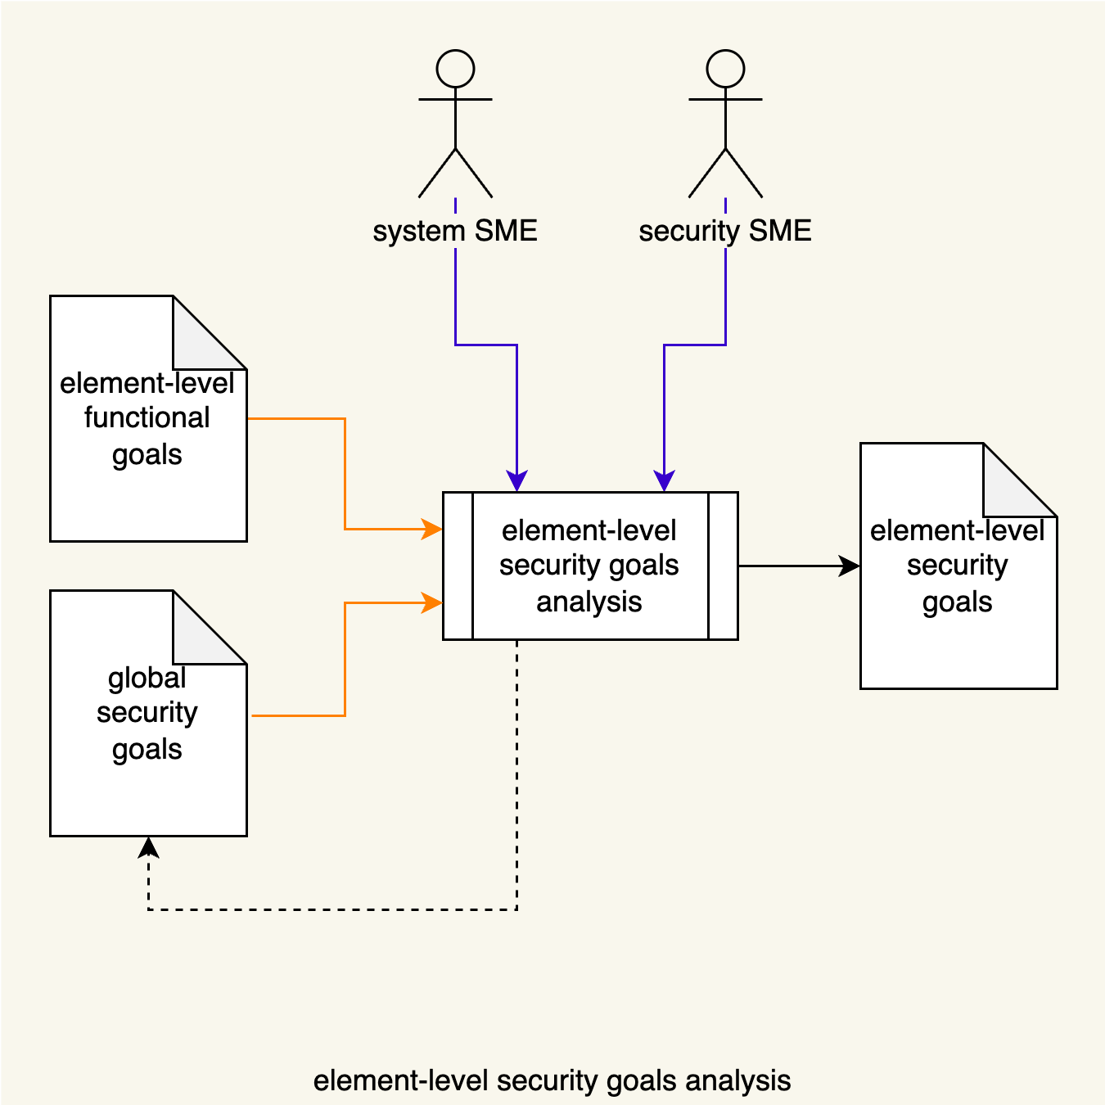

Using the **global security goals**, the Security SME, together with System SME(s), review the **element-level functional goals** and determine the goals appropriate to the element under consideration. The **element-level security goals** list is produced. If gaps are identified in the global security goals, it will be updated.

# Element Cybersecurity Goals

1. The storage and transmission of data should be secure and should be controlled.
2. The vehicle and its backend supporting systems should be designed to be resilient to cyberattacks.
3. The vehicle and its backend support systems should be designed with the capability to detect cyberattacks and respond appropriately.

**Note:** These goals were adapted from the UN working group on autonomous vehicle cybersecurity **[1]**.

# References

1. UNECE trans WP.29 GRVA 2019 2 - **World Forum for Harmonization of Vehicle Regulations: Proposal for a Recommendation on Cyber Security**  
   [**https://unece.org/fileadmin/DAM/trans/doc/2019/wp29grva/ECE-TRANS-WP29-GRVA-2019-02e.pdf**](https://unece.org/fileadmin/DAM/trans/doc/2019/wp29grva/ECE-TRANS-WP29-GRVA-2019-02e.pdf)